REFORM CONGREGATION KENESETH ISRAEL’S RABBINIC TIMELINE

Solomon Deutch (1816 - 18??) 1857-1860 Senior Rabbi
David Einhorn (1809 – 1879) 1861-1866 Senior Rabbi
Samuel Hirsch (1815–1889) 1866-1886 Senior Rabbi
Joseph Krauskopf (1858 - 1923) 1887-1923 Senior RabbI
J. Leonard Levy (1865-1917) 1893 -1901 Rabbi, Assistant to Dr. Krauskopf
Henry J. Fisher (1902 - 1904) 1902 - 1904 Assistant Rabbi
Eli Mayer (1880 - 1920) 1904 - 1906 Assistant Rabbi
Isaac Landman (1880-1946) 1906-1916 Assistant Rabbi
James G. Heller (1892-1971) 1916-1920 Assistant Rabbi
Abraham J. Feldman (1893-1977) 1920-1925 1920 Assistant Rabbi
1924 became Associate Rabbi
William Fineshriber (1878 - 1968) 1924-1949 Senior Rabbi
Julian B. Feibelman (1897 - 1980) 1926-1936 Assistant Rabbi
Samuel Cook (1907 - 1998) 1937-1940 Assistant Rabbi
Joseph Klein (1912 - 1996) 1940-1946 Assistant Rabbi
Malcolm Henry Stern (1915 - 1994) 1941-1947 Assistant Rabbi
Myron Silverman (1911-1981) 1947-1949 Assistant Rabbi
Bertram W. Korn (1918–1979) 1949-1979 Senior Rabbi
Theodore S. Levy (1926-2004) 1951-1952 Assistant Rabbi
H. Hirsch Cohen 1952-1957 Assistant Rabbi
Benjamin Marcus (1924-1985) 1957-1958 Assistant Rabbi
Arnold Kaiman (1933- 2007) 1959-1967 Assistant Rabbi
Arnold Fink (1936- 2005) 1962-1969 Assistant Rabbi
Alan D. Fuchs (1936 - ) 1968-1977 Assistant Rabbi
Laurence H. Rubinstein 1968-1972 Assistant Rabbi
David Powers 1972-1977 Assistant Rabbi
Stephen G. Franklin 1977-1979 Assistant Rabbi
Mark J. Mahler 1978-1980 Assistant Rabbi
Simeon J. Maslin (1931 - ) 1979-1997 Senior Rabbi
Steven M. Fink (1952 - ) 1979-1983 Assistant Rabbi
Sheldon Ezring (1948 - ) 1983-1986 Associate Rabbi
Joel Alpert 1983 - ???? Assistant Rabbi
Meir Lasker ( - ) 1941 Sr. Rabbi from Temple Judea
1983 he became KI Rabbi Emeritus
Richard Harkavy 1986-1989 Assistant Rabbi
Shoshana Perry 1989-1991 Assistant Rabbi
Deborah Pipe-Mazo 1991 - 1993 Assistant Rabbi
Joseph Forman 1993 - Assistant Rabbi
Bradley Bleefeld 1997-2001 Senior Rabbi
Lance J. Sussman 2001- present Senior Rabbi
Peter Rigler (1972 - ) 2002 - 2009 Assistant Rabbi
Kevin M. Kleinman 2009 - 2016 Assistant Rabbi

Solomon Deutsch (1816 - 18??)
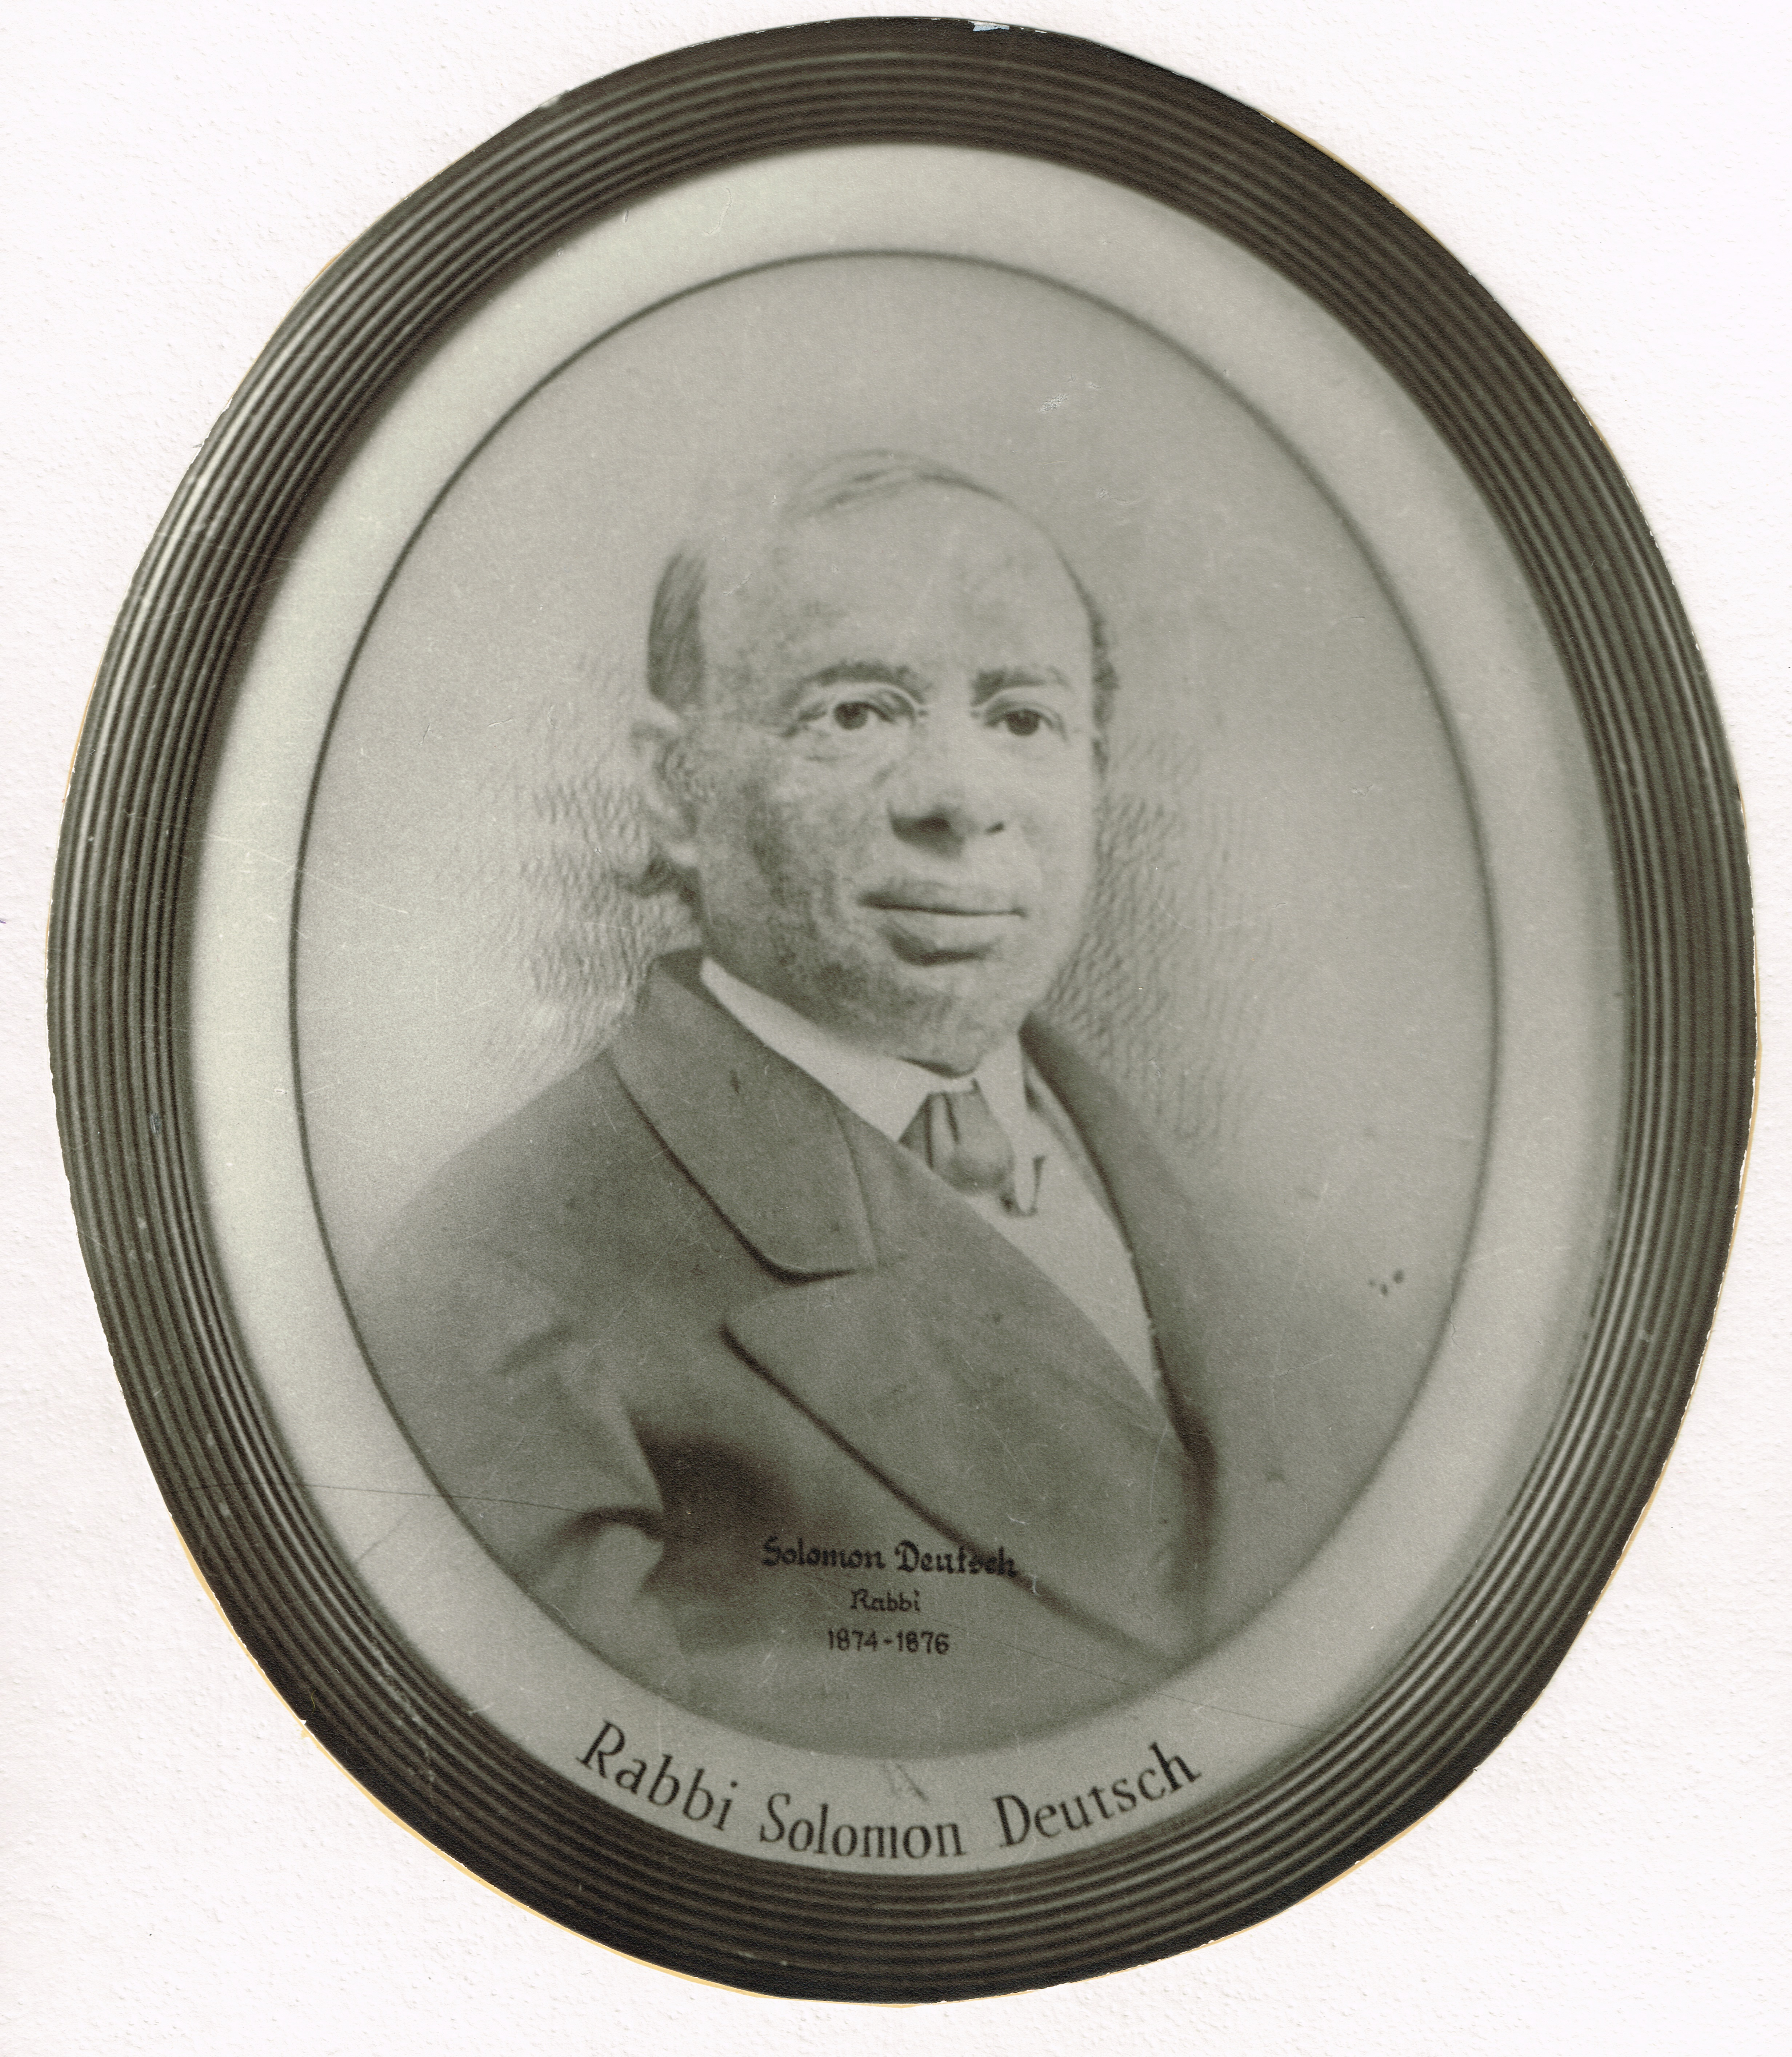
1857-1860 Senior Rabbi at Keneseth Israel

Solomon Deutsch born in the German state of Silesia in 1816. He was educated in the Universities of Breslan and Goettingen and served as a Rabbi of Posen, Germany. In 1857, he was elected as a Rabbi of the Congregation of Keneseth Israel. The Congregation helped to pay his expenses to come to the United States. During his time at KI, Rabbi Deutsch suggested various reforms. In 1858, he initiated two significant changes. First men and women could sit together. And secondly only Rosh Hashnah would be observed for two days. Dr. Deutsch and the Reader, Rev. L. Naumburg had disagreements about ritual matters and both men were dismissed from their posts in 1860.
After serving the congregation at Keneseth Israel, he moved to Syracuse, New York. Rabbi Deeutsch was a noted abolitionist and expressed his opinions at Keneseth Shalom Temple until 1864. Then he moved to Congregation Har Sinai in Baltimore.
In 1869, The Sabbath School Committee awarded a prize to Rabbi Samuel Deutsch for his book on Biblical History at the third Annual Council conference of the Union of American Hebrew Congregations. At this conference, Rabbi Deutsch, was one of twelve Rabbis, along with Rabbi Einhorn and Rabbi Hirsch to create (created) the famous Philadelphia Platform for the radical reform of Judaism in America. These documents became the framework for the 1885 Pittsburgh Platform.
In 1876, Dr. Deutsch served as the Rabbi of Congregation Beth Israel in Hartford Connecticut. In his sermons he questioned praying in Hebrew if you do not understand the language. He helped Beth Israel change from the use of an Orthodox prayer book to the 1877 Minhag America by Rabbi Isaac Mayer Wise. Several years after that later, they changed to the 1858 Olat Tamid, A Perpetual Blessing prayer book by Rabbi David Einhorn. In Rabbi Einhorn’s prayer book, prayers were translated into German and the services were shorter. Rabbi Deutsch also led his congregation into other reforms in American Judaism such as praying without covering their heads, and changes in funeral and mourning rituals. Dr. Deutsch’s efforts to bring about reforms in American Judaism caused a split in Beth Israel’s congregation. Rabbi Deutsch was among a few rabbis in America who were greatly affecting change with this sector of the Jewish community.

Resources:

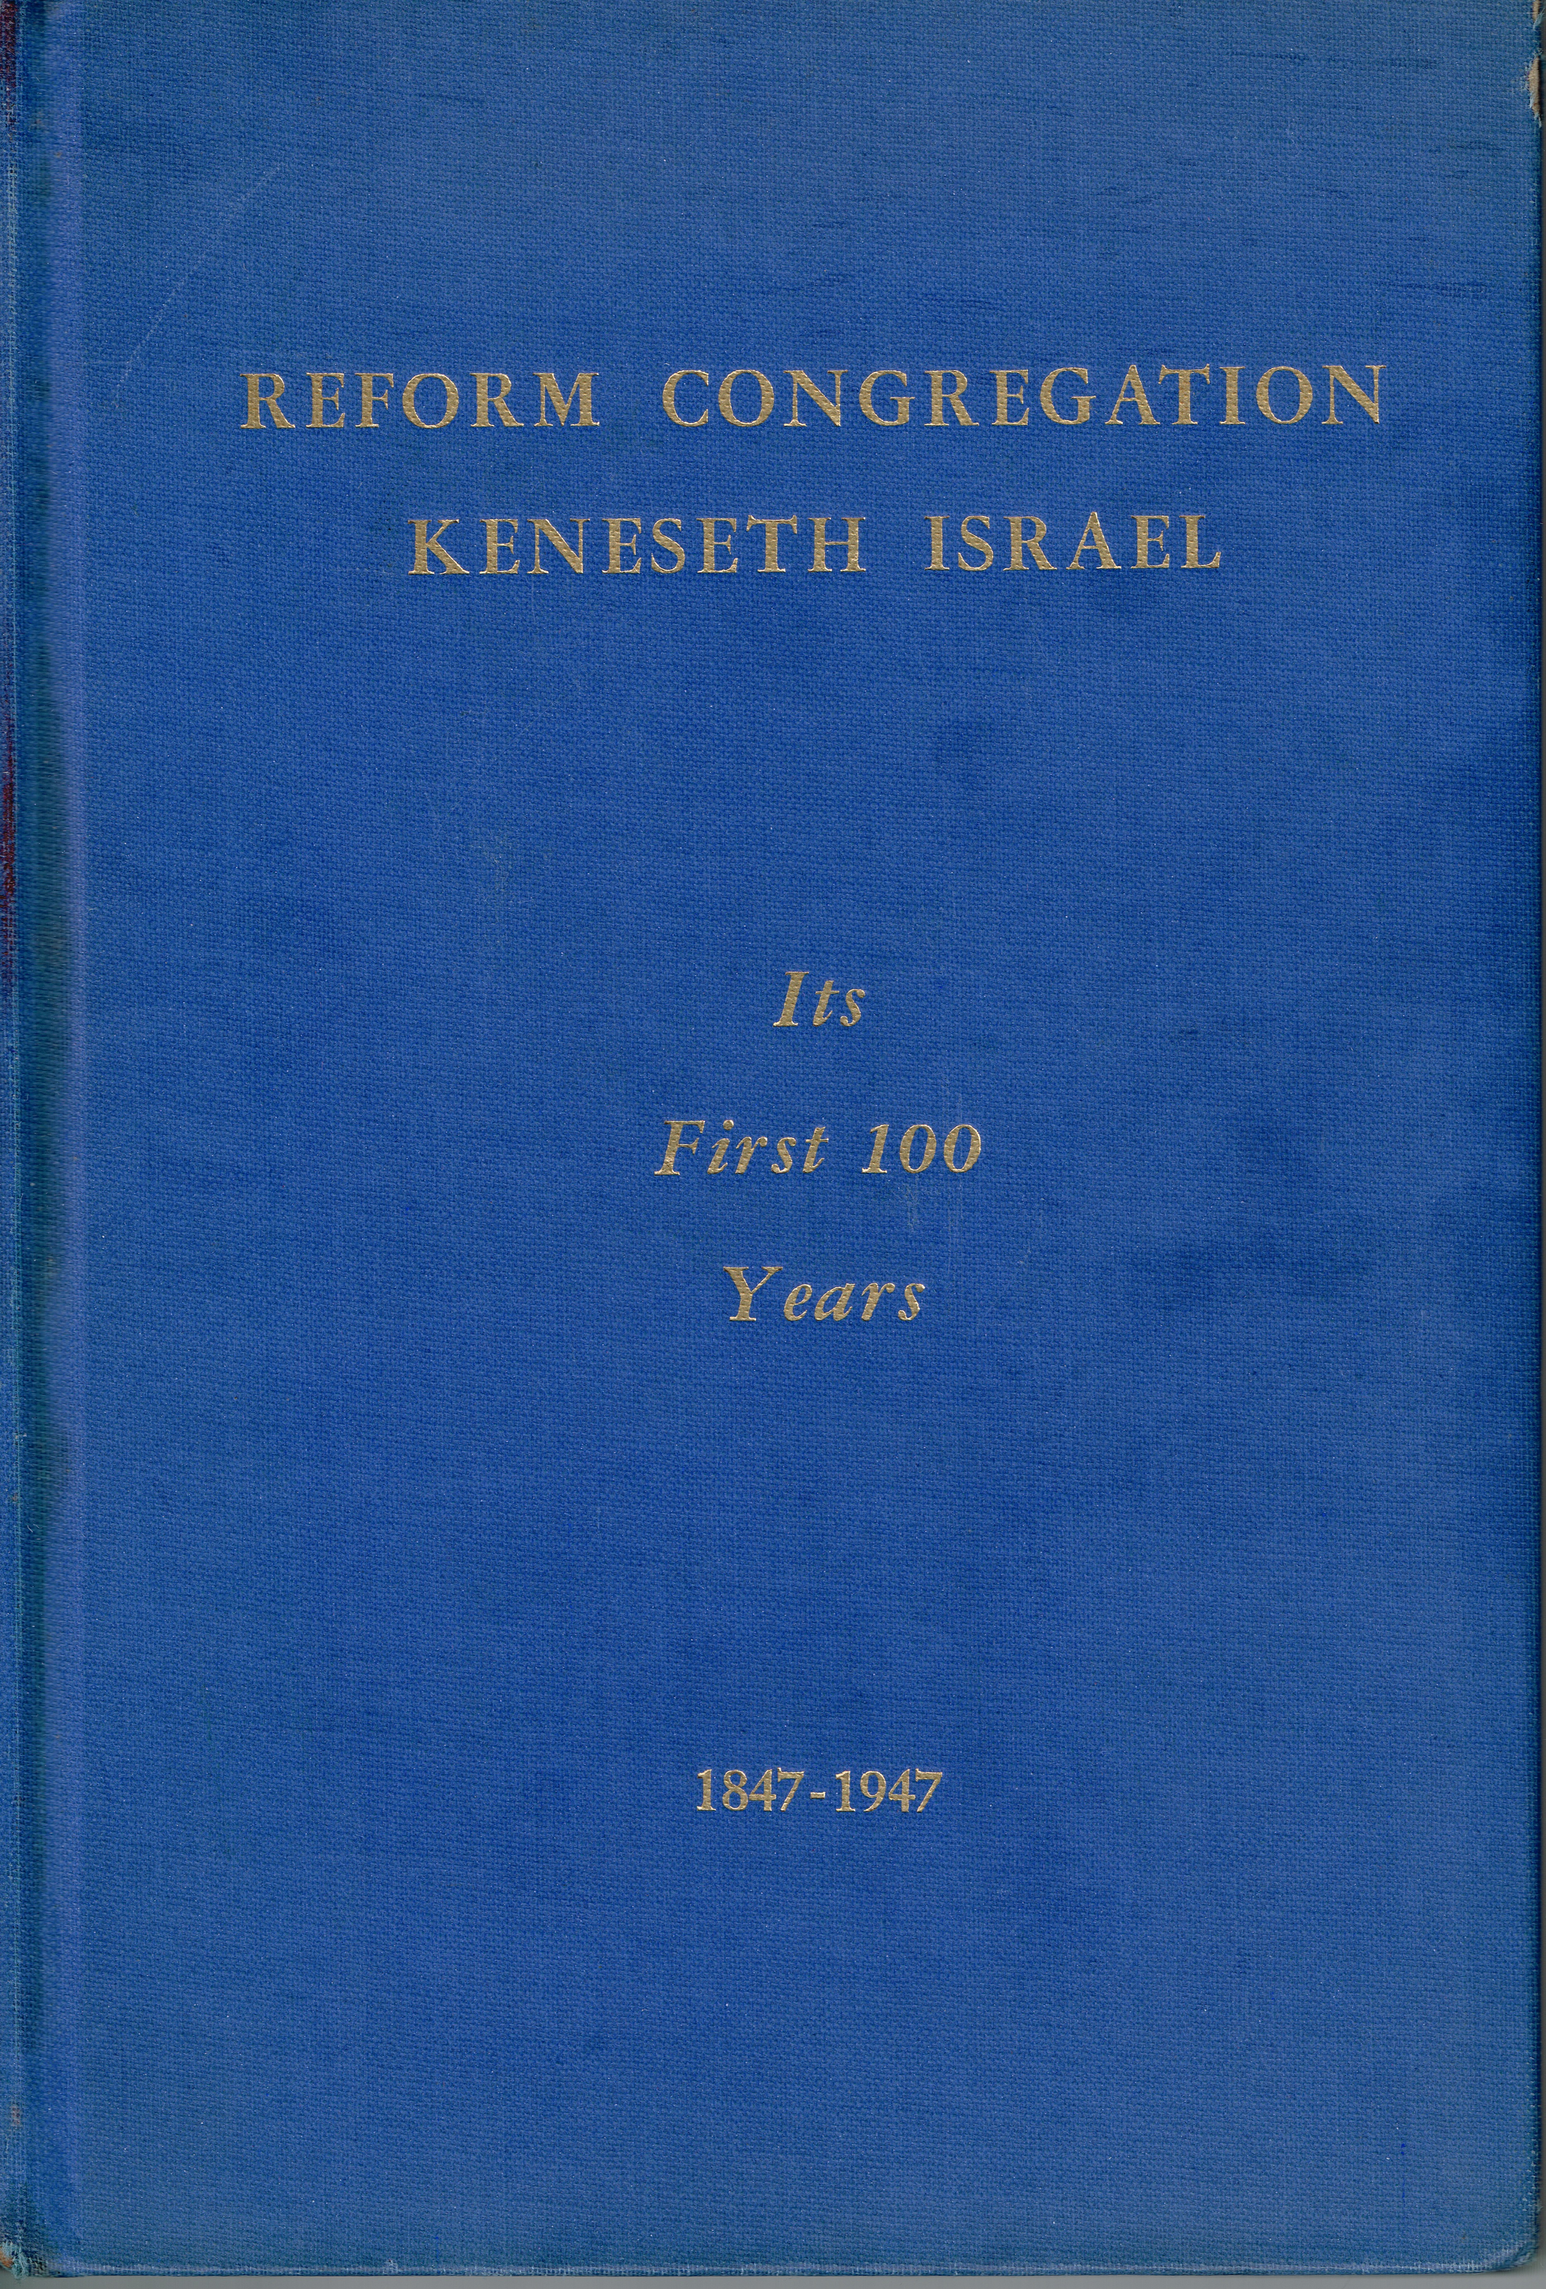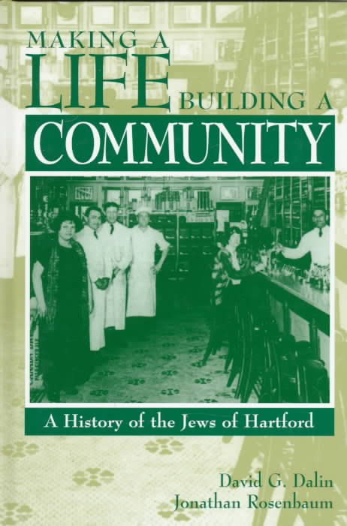

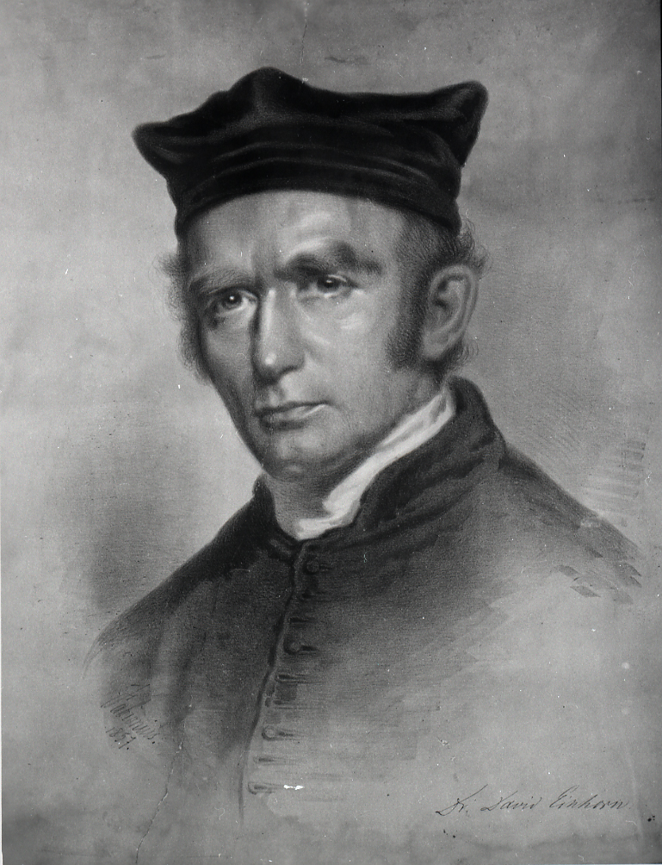
David Einhorn (1809 – 1879)

1861-1866 Senior Rabbi at Keneseth Israel

David Einhorn was born in Diespeck, Germany in 1809. At the age of 17, he earned his rabbinic ordination from the rabbinic school of Fürth and continued to study at the Universities of Erlangen, Munich and Würzburg; after he held the position of Chief Rabbi of Mecklenburg-Schwerin and in 1852 was called to lead the Reform congregation in Pesth, Hungary. As he as one of the early Reformers in Europe., Rabbi Einhorn was able to have an impact at the Frankfort Rabbinical Conference in 1845, Einhorn strongly pushed for having services in the vernacular and for cutting out all references to the restoration of the sacrifices and a Jewish state.
David Einhorn came to the United States in 1855. At the same time, KI I was looking for a leader. Rabbi Einhorn gave a sermon at Keneseth Israel but did not accept a call to the pulpit. He was presented with a loving cup for his services. Instead he accepted a position as the first rabbi of the Har Sinai Congregation in Baltimore. (Rabbi Deutsch also served at this congregation.)
While in Baltimore, Dr. Einhorn wrote the Olat Tamid prayer book. This book later served as one of the models for the Union Prayer Book published in 1892 by the Central Conference of American Rabbis.
Einhorn was an opponent of the Cleveland Conference of 1855 and its decision that the Talmud had primacy in interpreting the Torah. He stood in contrast to this opinion based on his training in Germany before he came to America.
Starting in 1856, Rabbi Einhorn started publishing the German language magazine, Sinai, which was devoted to Reform Judaism, and his beliefs both supporting antislavery, and as an opponent of opposing Interfaith marriage, the wearing of tefillin, limitations of activity on Shabbat and kosher dietary laws. In his Sinai magazine he felt that interfaith marriage was "a nail in the coffin of the small Jewish race". He supported keeping the portions of the Torah, which spoke to being a moral person.
After an angry mob surrounded his house following a particularly fiery Abolitionist sermon in 1861, his congregation encouraged him and his family to seek refuge in the north. Rabbi Einhorn came to Philadelphia and was promptly hired as K I 's Senior Rabbi. He was given freedom of the pulpit and continued his anti-slavery sermons. He agreed to preach three times a month and to supervise and teach in the religious school.
In 1866 he moved to New York City, where he became the inaugural rabbi of Congregation Adas Jeshurun on 39th Street, which merged with Congregation Anshei Chesed in 1873 and adopted the new name Congregation Beth-El and built a new structure on 63rd Street. Einhorn became the Rabbinic leader of the newly merged synagogue. After serving for many years, he delivered his final sermon on July 12, 1879, after which the congregation agreed to bestow upon him a pension of $3,500. Rabbi Einhorn remained in New York City until his death in 1879.

Resources:
http://www.jewishencyclopedia.com/articles/5483-einhorn-david
http://www.jewishvirtuallibrary.org/tributes-to-lincoln-after-his-death-judaic-treasures
https://en.wikipedia.org/wiki/David_Einhorn_(rabbi)

KI at 90

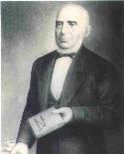
Samuel Hirsch (1815–1889)
1866-1886 Senior Rabbi at Keneseth Israel

Rabbi Samuel Hirsch was born at Thalfang, Prussia. He was university trained in Bonn. Dr. Hirsch served as rabbi in Dessau (1839–41), and as Chief Rabbi of Luxembourg (1843–66). Many of KI’s leaders were familiar with his writings on Reform Judaism. So while he was in Luxembourg, KI approached him and offered him a contract for life at $4,000 per year and $2,000 per year in case of retirement. He accepted their offer and moved to America.
In 1868, he founded the Orphan' Guardians. The Foster Home and the Association for Jewish Children were an outgrowth of this organization. Rabbi Hirsch served as President of the American Rabbinic Conference in 1869. This was the first conference of Reform Rabbis, which met in Philadelphia from Nov. 3 - 5, under his chairmanship.
Also, he was a founder of the Philadelphia branch of the Alliance Israelite Universalle. This group was the first international Jewish organization focused on philanthropy. Under Rabbi Hirsch, Keneseth Israel was very active in social justice causes. Congregants of KI participated in and were leaders of the United Hebrew Charities, the Jewish Hospital and Home, the Jewish Immigrant Aid Society, the Jewish Foster Home, and the Orphans Asylum and the Orphans Guardians, the Hebrew Relief Society, the Ladies Society for the Sick, Poor, the Ladies Sewing Society and Mrs. Rosa Sach’s Industry Training School. KI President Klein cited all of these charitable groups in his congregational address in May of 1887.
Rabbi Dr. Samuel Hirsch’s Reform innovations included: removal of men’s hats, a 7-year Torah reading cycle, discontinuance of Friday evening Services, founding of The Jewish Publication Society, eliminating the Bar Mitzvah and continuing the Confirmation service, establishing a library and abolishing the blowing of the shofar at services to name a few.
He spent the last year of his life in Chicago with his son Emil G. Hirsch, who was also an important Reform rabbi in the United States at that time.

Resources:
http://www.jewishvirtuallibrary.org/hirsch-samuel https://en.wikipedia.org/wiki/Samuel_Hirsch
https://www.jstor.org/stable/23878076 https://www.haaretz.com/jewish/this-day-in-jewish-history/1.720520
KI at 90 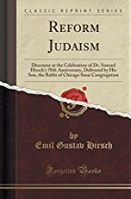

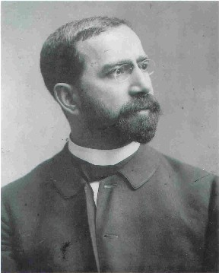
Joseph Krauskopf (1858 - 1923)
1887-1923 Senior Rabbi at Keneseth Israel

Joseph Krauskopf was born in Ostrów Wielkopolski, Poland and later came to the U.S. as a teenager. His family settled in Fall River, Massachusetts. He was a member of the first graduating class (1883) of the Hebrew Union College in Cincinnati, Ohio. In 1885, he received his Doctor of Divinity from the Hebrew Union College.
In 1885, Rabbi Krauskopf was the Vice President of the Pittsburgh Conference on Reform Judaism. He contributed to the writing of the Pittsburgh Platform. This document is considered the defining document of classical Reform Judaism. In 1887, he agreed to become the Rabbi of Keneseth Israel after a brief but noteworthy service in Kansas City.
Krauskopf helped guide the congregation's effort to build the large neoclassical complex on North Broad Street. He was an impressive orator, Rabbi Krauskopf's Sunday discourses attracted large crowds, many of whom joined the synagogue, transforming KI into the largest synagogue in the United States at the beginning of the 20th century.
Rabbi Krauskopf influenced and changed Keneseth Israel in may different ways:
- De-emphasizing of Friday Sabbath services and encouraged attendance at the Sunday morning "discourses" which were published and sold throughout the country.
- He Significantly reorganized the Religious School. He and made its structure more like the public schools of the day. Rabbi Krauskopf added training for teachers and most of the new teachers were certified public school teachers.
- Establishing an organized a formal library in Nov 1890. This was a free lending library to the congregation and the neighborhood.
- Encouraging Encouraged congregants to participate in many charitable acts such as the Sewing Circle, which donated clothing to those in need, and volunteer at an early form of a Community Center called The Home of Delight.
- Organizinged of a group called the “Knowledge Seekers,” to advance the knowledge of Judaism within themselves and the congregation.
- In 1888, he eliminated the reading from the Torah, the language of the service was changed to English to include more people in the process of prayer.
- In 1897, he created Post-Confirmation in a joint effort with Congregation Rodeph Shalom.
- In 1891 KI established Rules of Decorum during services
- In 1909 Yom Kippur, Succoth and Pesach Children’s Services were conducted.
- In 1911 the study of Hebrew was made elective.
- In 1911 Founding of the KI Sisterhood.
- In 1917, Services were temporarily discontinued due to WWI.

Rabbi Krauskopf sought innovative philanthropic projects for his congregation to participate in due to the many poor Jewish immigrants in the late 1890's and early part of the twentieth century. And after his trip in the summer of 1894 to Europe and Russia to study social conditions, he decided to work towards making a difference. In 1896, he founded the National Farm School in Doylestown, PA as both a place where young men from disadvantaged neighborhoods could learn agricultural skills and as a living example of how Jewish agrarian roots could be reawakened in America. Today, The National Farm School is Delaware Valley University.
KI had always considered itself to be an integral part of the community life of Philadelphia. In this spirit, a memorial service to George W. Childs, the publisher of The Ledger occurred. In 1905, a memorial window was dedicated to the memory of John Hay who had been a Secretary to President Lincoln during the Civil War and who had been a devoted friend of the Jews. A window created by Edith Emerson with guidance from Violet Oakley, was dedicated in the Nov 2, 1919 to the memory of Theodore Roosevelt, 26th President and friend of Jews. We also have a sculpture to of Franklin D. Roosevelt, our 32nd president.
Rabbi Krauskopf served from 1903-1905 as president of the Central Conference of American Rabbis. And in 1903 Dr. Krauskopf was appointed Chairman of the Isaac M. Wise Memorial Fund Committee. Due to this appointment, the Sunday services were terminated. In the summer of 1904, Rabbi Eli Mayer was elected as Assistant to Dr. Krauskopf.
In 1908, the Union of American Hebrew Congregations held its convention in Philadelphia. Keneseth Israel and Rodeph Shalom co-hosted this event. During the Convention the Isaac M. Wise Window was dedicated. Moses Ezekiel designed this the window.
In 1922 Rabbi Krauskopf was granted a leave of absence to enable him to devote his energies to raising a Jubilee Fund for the National Farm School.
A prolific writer, Krauskopf published hundreds of discourses, many of which reported on his worldwide trips including to the early kibbutzim in Ottoman Palestine and on his trip to the Far East. He was also the author of a number of important books including works on religion and science, anti-Semitism, Jewish-Christian relations and Jewish history. During his lifetime, he was widely recognized as one of America's leading pulpit rabbis.
Memorial Services were held for Dr. Krauskopf on Sunday, November 4, 1923.
Rabbi Krauskopf served Keneseth Israel for 36 years.

Resources:
https://kenesethisrael.org/rabbi-joseph-krauskopf
https://en.wikipedia.org/wiki/Joseph_Krauskopf
http://collections.americanjewisharchives.org/ms/ms0183/ms0183.html

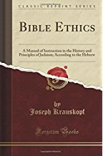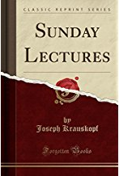

J. Leonard Levy (1865-1917)
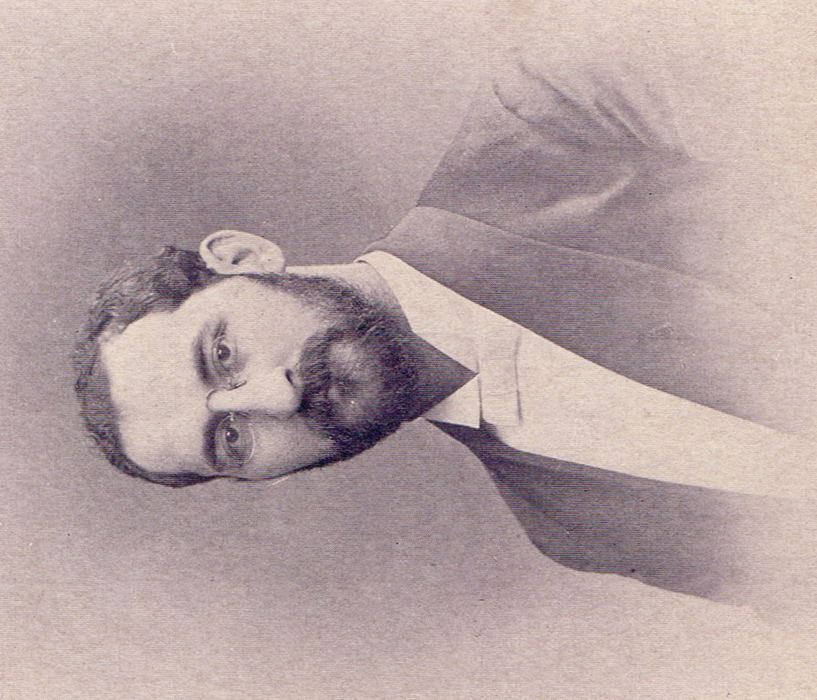
1893 -1901 Assistant to Dr. Krauskopf at Keneseth Israel

J. Leonard Levy was born in London, England and attended the University of London and the Jews’ Theological College. His first rabbinic assignment was in Bristol, England. When he came to the United States and he served as a Rabbi in Sacramento, California.
Then he came to KI in 1893. He gave many Sunday Discourse sermons to the congregation. They were of his own thoughts as well as sharing points from Rabbi Krauskopf when he was away from the congregation. In 1898, he took a short leave of absence from KI to serve as a chaplain with Col. Kagan’s brigade in the Spanish American War.
J. Leonard Levy, a dynamic leader with an internationalist outlook. In 1901 he was offered a full time pulpit in Pittsburgh, PA at Rodef Shalom. Rabbi Levy should be noted for his work to strengthen interfaith communication in Pittsburgh and beyond. During his time at Rodef Shalom, he started an international peace organization and co-edited the weekly Jewish Criterion. He continued to preach at both Sabbath and Sunday services.
At Rabbi Levy’s invitation, President William Howard Taft visited Rodef Shalom on Saturday, May 29, 1909. This was the first time that a sitting United States president spoke from the bimah of a Jewish congregation during regular Sabbath services.
During J. Leonard Levy’s rabbinate (1901-1917), Rodef Shalom’s congregation nearly tripled in size. New immigration patterns brought more Jews to the city and new demographic patterns saw many of these new arrivals and longer-standing congregants moving from Allegheny City and the Hill District to emerging eastern neighborhoods like Oakland, Shadyside, and East Liberty.
Rabbi Levy was a man of firm convictions and strong personality. He was an influential leader of the Reform Movement in America. His teachings and engagement with the world still resonate with today's issues of social justice, interfaith cooperation, and civic character.
Rabbi Levy died at age 51 from pneumonia. His funeral service at Congregation Rodef Shalom was well attended.

Resources:
https://rodefshalom.org/about/history
https://jewishchronicle.timesofisrael.com/rabbi-levys-legacy-still-relevant-today-to-be-celebrated-at-rodef-shalom/

http://histoxzricpittsburgh.org/islandora/object/pitt%3A20121102-hpicrsc-0009
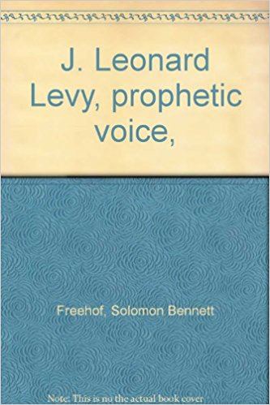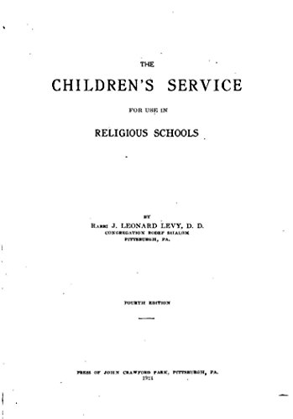

Henry J. Fisher (18 - ???? )
1902 - 1904 Assistant Rabbi at Keneseth Israel

He came to KI to help Rabbi Krauskopf on Thursdays and Sundays. Rabbi Fisher helped with the Religious School and the weekly Bulletin.

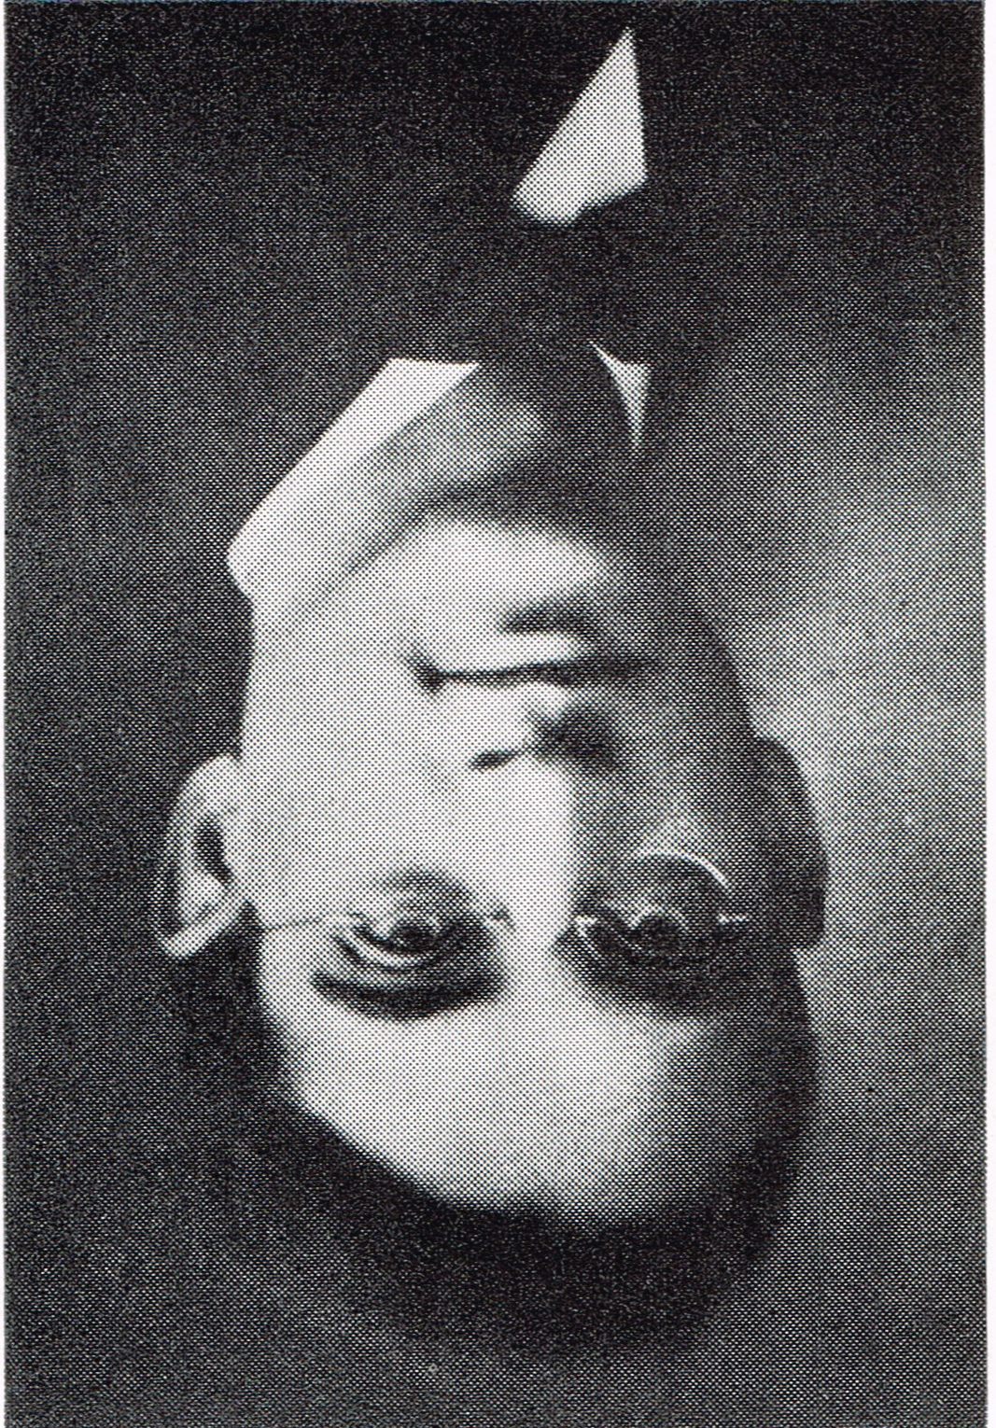
Eli Mayer (1880 - 1920)
1904 - 1906 Assistant Rabbi at Keneseth Israel

1880 He was born on January 27, 1880 in Baltimore, Md.
1887 Rabbi Eli Mayer, Bachelor of Arts in Newark, NJ.
1902 Eli Mayer graduated from both the Hebrew Union College and a Master of Arts from the University of Cincinnati.
1902 - 1904 Rabbi Mayer was Assistant Rabbi in Helena, Ark.
1904 - 1906 In the summer Eli Mayer was elected as the Assistant to Dr. Krauskopf. He served as reader and officiated at weddings and funerals. In 1906 Rabbi Mayer resigned to take another position.
1906 - 1908 Rabbi of the Patterson, NJ Congregation
1908 - 1920 Eli Mayer was Assistant Rabbi at Rodeph Shalom in Philadelphia. 1908 he was appointed Assistant Rabbi. In 1915 he was given the title of Associate Rabbi to Rabbi Berkowitz. On December 1, 1917, Rabbi Mayer gave an address in the Saturday Morning Shabbat Program and was a singer in the choir at Rhodeph Shalom when Rabbi Berkowitz was honored for 25 years of service. His wife, Mrs. Eli Mayer played the violin and also sang in the choir on the auspicious occasion of the Silver Jubilee of Rodeph Shalom.
1918 * “War and Religion: A Sociological Study“ Philadelphia: University of Pennsylvania, An interesting thesis by Rabbi Eli Mayer to the faculty at the University of Pennsylvania for the degree of Doctor of Philosophy.
* During the summer of 1918 Rabbi Mayer gave several lectures for The Jewish Chautauqua Society at State College, Pa and at the University of Kentucky.

* In the New Deal Era, at the time of the creation of the National Association for the Advancements of Colored People, Rabbi Eli Mayer sat on the NAACP’s branch of the Board of Directors.

1918 - 1920 Dr. Mayer was Rabbi at Temple Beth Emeth, Albany, NY at the time of his unexpected passing. At the point of his passing, he was survived by his widow.

1921 In the Union of American Hebrew Congregations 1921 Report it stated that Rabbi Eli Mayer’s classmates from 1902 requested and set up a significant amount of money in the Student’s Emergency Loan Fund in his memory.

Resources:
Rodeph Shalom Annual 25 Silver Jubilee
https://books.google.com/books?id=um0UAAAAYAAJ&pg=PA11&dq=Eli+Mayer&hl=en&sa=X&ved=0ahUKEwi1kbP668bYAhVhhuAKHSyJC2IQ6AEIRjAG#v=onepage&q=Eli%20Mayer&f=false

The American Hebrew and Jewish Messenger, Vol 107, Issues 1-13, pg 313
https://books.google.com/books?id=_FtAAQAAMAAJ&pg=PA313&lpg=PA313&dq=%22Rabbi+Eli+Mayer%22&source=bl&ots=t8GhLhNEvc&sig=T2P9uT9H_SVa0h8mHMmKQC85HY&hl=en&sa=X&ved=0ahUKEwjNxcX1zLrXAhUD4SYKHeVeCH0Q6AEISzAH#v=onepage&q=%22Rabbi%20Eli%20Mayer%22&f=false

The Advocate: America’s Jewish Journal Vol: 55, pg 403
https://books.google.com/books?id=BpHlAAAAMAAJ&pg=PA403&lpg=PA403&dq=%22Rabbi+Eli+Mayer%22&source=bl&ots=7s1s0wFqnx&sig=w4dfdTUIbKQYHOlet6Q5kyaha9U&hl=en&sa=X&ved=0ahUKEwiZlv6G0LrXAhWBLSYKHdUmAvs4ChDoAQgxMAM#v=onepage&q=%22Rabbi%20Eli%20Mayer%22&f=false

Philadelphia Divided: Race and Politics in the City of Brotherly Love by James Wolfinger p.22
https://books.google.com/books?id=MhM9Fw2xQ5QC&pg=PA22&dq=%22Rabbi+Eli+Mayer%22&hl=en&sa=X&ved=0ahUKEwj256Ld0rrXAhWH0iYKHZveDkEQ6AEIUzAI#v=onepage&q=%22Rabbi%20Eli%20Mayer%22&f=false

The American Jewish Archives Journal, Vol. 56-57, pg.88
https://books.google.com/books?id=v-AMAQAAMAAJ&focus=searchwithinvolume&q=Eli+Mayer

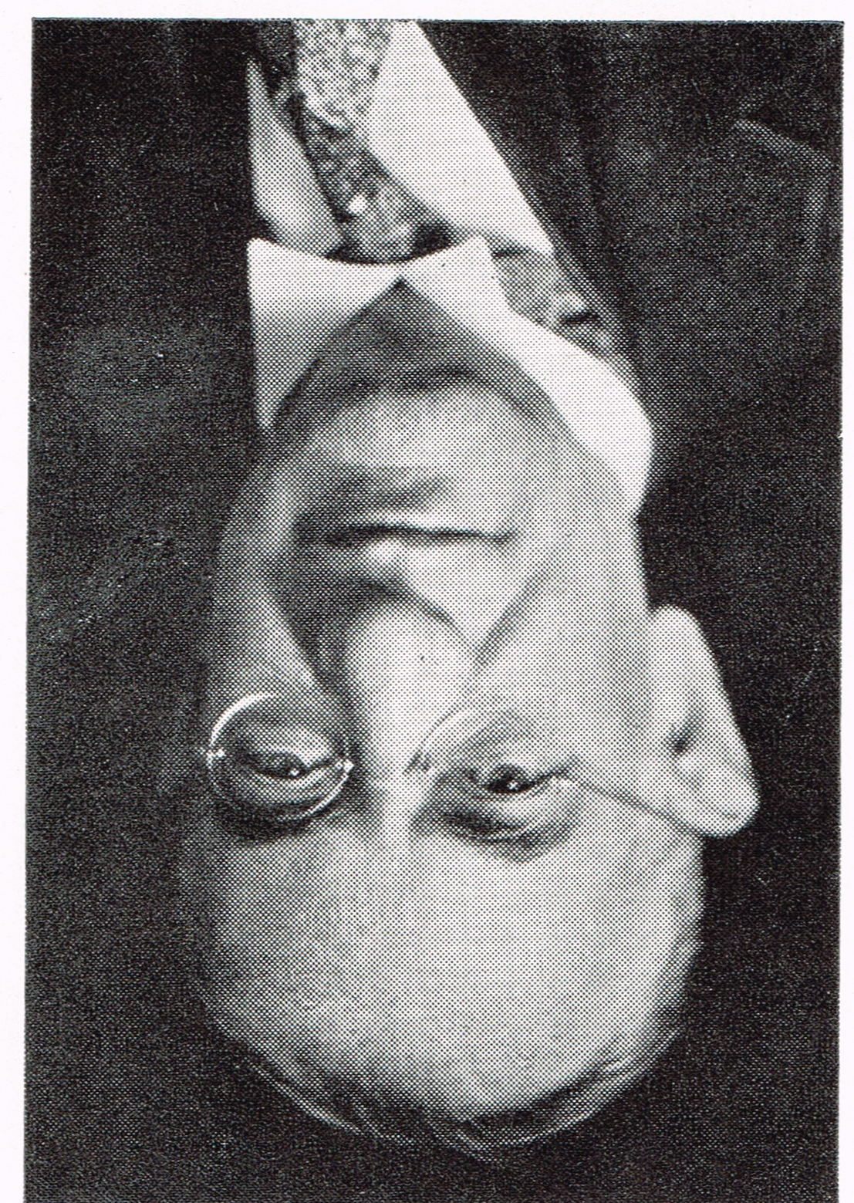
Isaac Landman (1880-1946)
1906-1914 Assistant Rabbi at Keneseth Israel

Isaac Landman was born in Russia on October 4, 1880. He emmigrated to the United States in 1890. He graduated from the Reform Hebrew Union College.
In 1911, with Jacob Schiff, Julius Rosenwald, and Simon Bamberger, he founded a Jewish farm colony in Utah. During World War I he was "said to be the first Jewish chaplain in the United States Army to serve on foreign soil"
In June 1906, he was elected as Assistant Rabbi at Keneseth Israel. Rabbi Landman and Rabbi Krauskopf developed a syllabus so that the Bible might be used as a textbook in the KI Religious School. This was a new concept.
In 1914 Rabbi Landman resigned from KI.
During World War I, he served as a Jewish Chaplain in the Army.
Rabbi Landman served as a delegate of the Union of American Hebrew Congregations to the 1919 Paris Peace Conference. He was an opponent of Zionism. In 1922, Rabbi Landman and Rabbi Philipson represented the Reform movement’s position, which was anti-Zionist, to the U.S. Congress’s House Committee on Foreign Affairs. President Harding and the Congress supported the Lodge-Fish resolution.
Rabbi Landman was a leader in Jewish–Christian ecumenism. During his career, he was an editor of the American Hebrew Magazine.
In 1931, he became rabbi of Brooklyn's Congregation Beth Elohim. In 1934, he began editing the Universal Jewish Encyclopedia, which was published in ten volumes in the 1940s. Landman was also a playwright. With his brother, physician Michael Lewis Landman. They authored the play A Man of Honor.
He died on September 4, 1946.
Resources:
https://en.wikipedia.org/wiki/Isaac_Landman

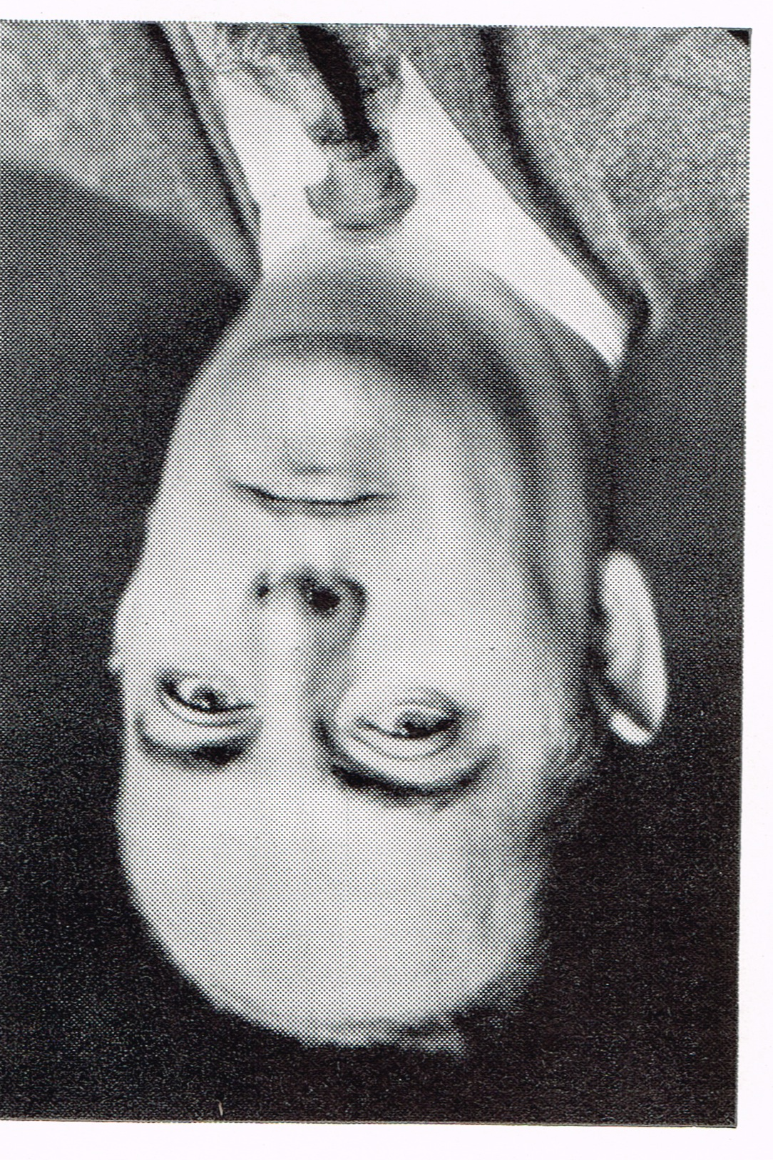
James G. Heller (1892-1971)
1916-1920 Assistant Rabbi at Keneseth Israel

Rabbi Heller was born in New Orleans and was a graduate of Tulane University. Following his ordination at the Hebrew Union College‐Jewish Institute of Religion in Cincinnati, he came to KI.

Rabbi James Heller had the distinction of being installed as Assistant Rabbi at Keneseth Israel by his father, Rabbi Max Heller of New Orleans. In 1917 Rabbi Heller requested permission to serve as a chaplain in the Army of World War I. He was a chaplain with the American expeditionary force. The congregation continued his full salary while he was in the service. In 1920 Rabbi Heller resigned from his service at Keneseth Israel.

Then he went on to Little Rock, Ark. From 1920 as Assistant Rabbi, 1926 Senior Rabbi until 1952 he was rabbi of the Isaac M. Wise Temple. While he was the Senior Rabbi of the Isaax M. Wise Temple, he also participated many other aspects of American Judaism. In 1930, he also became an active part of the Labor Zionist Organization of America. In 1941-1943, Dr. Heller was a President of the Central Conference of American Rabbis. He also served as a member of the Hebrew Union College‐Jewish Institute of Religion Board of Governors and of the Executive Committee of the Union of American Hebrew Congregations. In 1945, he was National Chairman of the United Jewish Appeal.

For many years Dr. Heller wrote the program notes for the Cincinnati Symphony Orchestra. His oratorio “Watch man, What of the Night?” was performed at the Cincinnati May festival in 1939. He was a former professor of musicology at the Cincinnati College‐Conservatory of Music.

Dr. Heller served on the Cincinnati Board of Education and on the Board of the Cincinnati Planned Parenthood Association. He was the author of a biography of the founder of American Reform Judaism entitled “Isaac M. Wise—His Life, Work and Thoughts” and also of a history of the Wise Temple.

Rabbi Heller passed away in 1971 at the age of 79. He was kindly memorialized in the New York Times.

Resources:
http://www.nytimes.com/1971/12/20/archives/rabbi-james-g-heller-is-dead-ade-ito-saaim-r9t.html

https://en.wikipedia.org/wiki/James_G._Heller

Reform Congregation Keneseth Israel, It’s First 100 years 1847-1947.

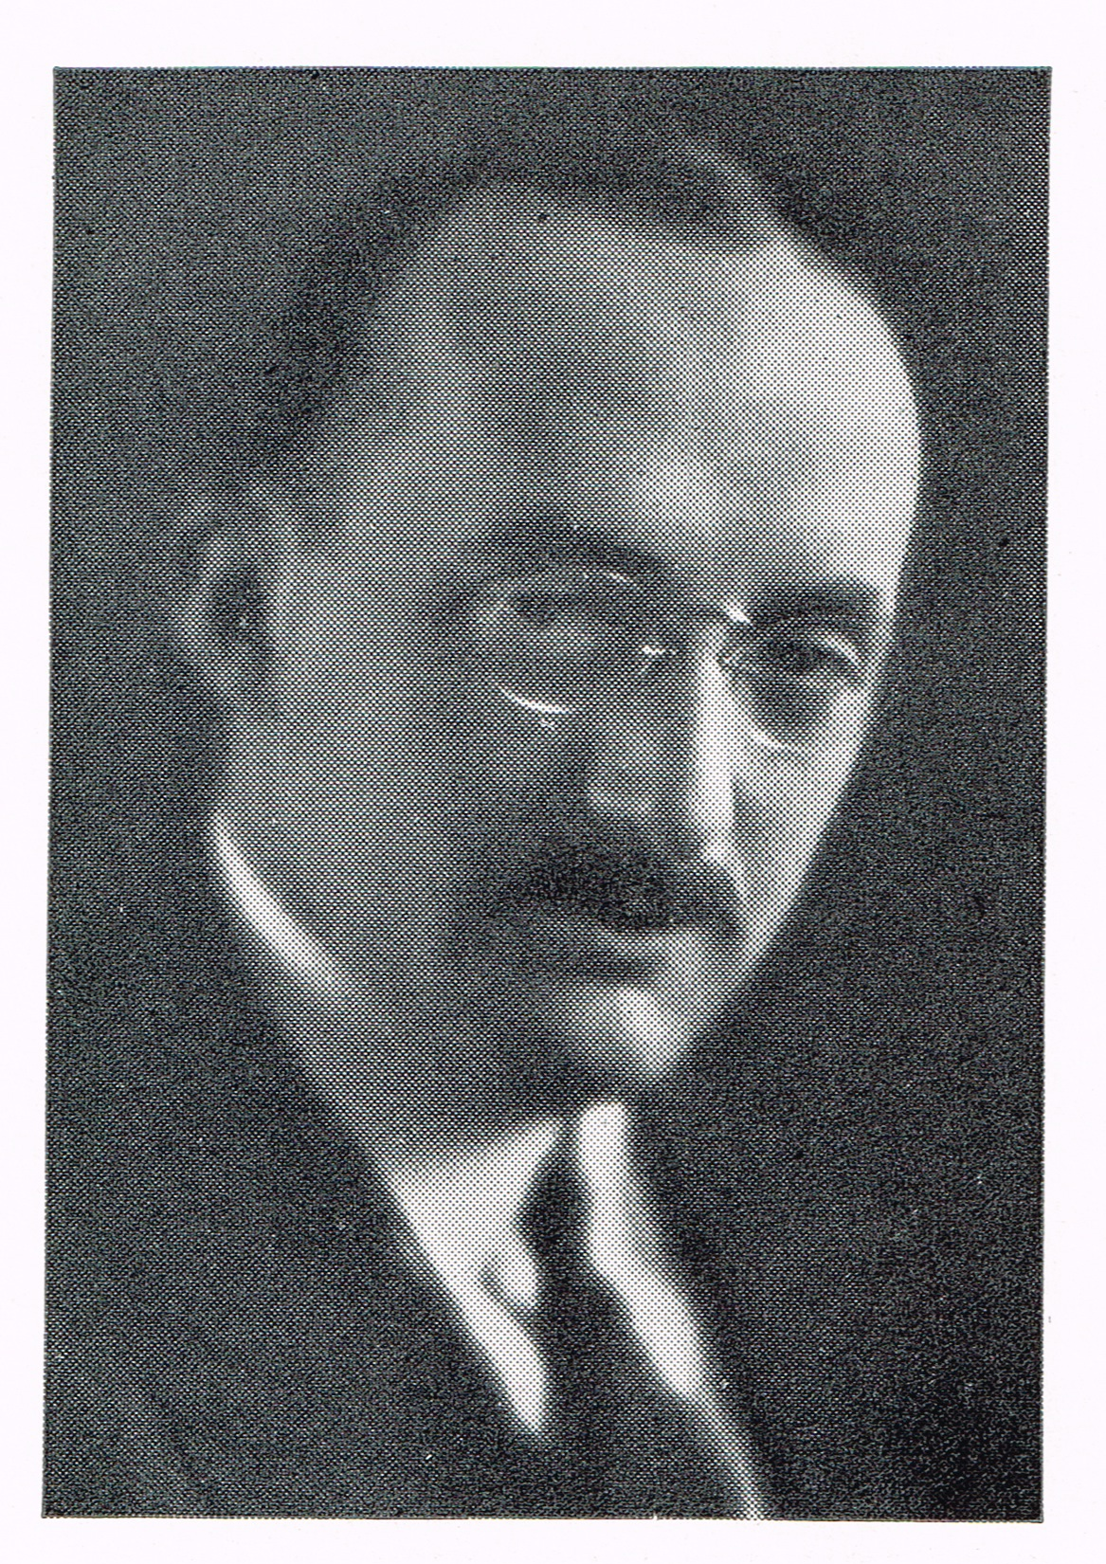
Abraham J. Feldman (1893-1977)
1920-1925 Assistant, then Associate and
Interim Senior Rabbi at Keneseth Israel

Abraham Jehiel Feldman, Reform rabbi, author, and civic leader, was born on June 28, 1893 in Kiev, Ukraine. In 1906 he came to the United States with his parents and they settled on the Lower East Side of Manhattan in New York City.
He attended Columbia University and received a BHL (1913), the University of Cincinnati where he received an A.B. (1917), and the Hebrew Union College in Cincinnati, where he was ordained as a Rabbi (1918).
After graduation Rabbi Feldman served as Associate Rabbi to Stephen S. Wise at the Free Synagogue in New York City (1918-1919); as Rabbi at Congregation Children of Israel in Athens, Georgia (1919-1920); as an associate, then acting, Rabbi at Congregation Keneseth Israel in Philadelphia (1920-1925). This was because of the unexpected passing of Rabbi Krauskopf in 1923. While at KI he suggested the creation of the Men’s Club in 1922.
After serving at KI he became a Rabbi at Congregation Beth Israel in West Hartford, Connecticut (1925-1968). In 1968 he was elected Rabbi Emeritus of Congregation Beth Israel.
A nationally known Jewish leader, Feldman served as President of the Central Conference of American Rabbis (1947-1949). He served as an officer of the Synagogue Council of America (1955-1957), the Jewish Ministers of Philadelphia, the Federation of Jewish School Teachers of Pennsylvania, the Jewish Teacher's Association of New England Liberal Schools, the Alumni Association of the Hebrew Union College (1945-1947), and the World Union for Progressive Judaism (1947-1949). He was on the Board of Directors of the National Farm School (Doylestown, Pennsylvania), United Jewish Charities, and Mt. Sinai Hospital (Hartford). He was an active member of the Board of Managers of the Department of Synagogue and School Extension of the Union of American Hebrew Congregations, and a member of the governing board of the American Jewish Committee, and the Military Chaplains Association.
His leadership in community affairs is demonstrated through his involvement in the Connecticut Birth Control League, Hartford Music Foundation, the Connecticut Advisory Committee of the United States Commission on Civil Rights, the University of Hartford, Hartford Rotary Club, various offices within the Masonic movement in the United States and Israel, and the American Jewish Historical Society.
Rabbi Feldman was the author of numerous publications during his lifetime. His writing career was extensive. Some examples are Associate Editor of the English-Yiddish Encyclopedia Dictionary (1910-1912), 1929 founder and editor of the Connecticut Jewish Ledger, 100 Benedictions (1948), Confirmation (1949), Reform Judaism: A Guide for Reform Jews (1953), and American Reform Rabbi (1965). He was also a contributor to a number of encyclopedias. Rabbi Feldman received honorary degrees from Hebrew Union College (D.D., 1944), Trinity College (STD, 1953), Hillyer College (LL.D., 1953), Hart College of Music (D.Hum., 1953), the University of Hartford, and Parsons College.
Abraham Feldman died on July 21, 1977 after a brief illness. He was 84 years of age.

Resources:
http://collections.americanjewisharchives.org/ms/ms0038/ms0038.html

http://www.worldcat.org/title/gods-fools-sixteen-discourses/oclc/10444415

http://www.worldcat.org/title/religion-in-action-twelve-discourses-delivered-before-reform-congregation-keneseth-israel-philadelphia-pa/oclc/45172513

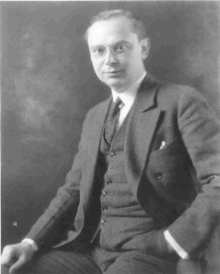
William Fineshriber (1878 - 1968)
1924-1949 Senior Rabbi at Keneseth Israel

Fineshriber was born in St. Louis, Missouri and later lived in Evansville, Indiana, where his father was a Rabbi. He was a graduate of Hebrew Union College, Dr. Fineshriber became KI's first American born Rabbi.
In 1900, upon graduation from the Hebrew Union College and the University of Cincinnati he served congregations in Davenport, Iowa and Paducah, and Kentucky. He was in Memphis, Tennessee in 1911 as Assistant Rabbi at the Congregation Children of Israel. Upon the unexpected passing of Rabbi Samfield, he became their Chief Rabbi in 1915. Rabbi Fineshriber was serving in Memphis when the committee from Keneseth Israel came to hear him and talk with him. At the April 8, 1924 meeting, Rabbi Fineshriber was ratified as Rabbi of the Congregation of Keneseth Israel.
In the Fall of 1924, he urged a few changes: to add the reading of the Torah on Saturdays and High Holy Days, covering of the Torah with attractive robes and adding a violin or cello to the Choir and a short musical service on Sundays and the adoption of the Union Prayer Book for services other than Sundays. The Krauskopf Hymnal and the Sunday Services continued.
1n the summer of 1925 after the resignation of Rabbi Feldman, Rabbi S. Ferdinand Becker was living in Philadelphia and helped with funerals and Friday evening services.
In June of 1927, Temple University awarded Rabbi Fineshriber an honorary Doctor of Divinity for distinguished service to the University and to Philadelphia.
Among the many innovative influences he had on the congregation were the restoration of the position of cantor, the 1924 adoption of the use of the Union Prayer Book, the expansion of the religious school, in 1929, the establishment of an emergency fund to help the needy during the Great Depression, and in 1931, the re-establishment of the Bar Mitzvah ceremony. In 1924, the reading of the Torah at Sabbath services
1934, during the annual meeting, the congregation elected to honor Dr. Albert Einstein with an honorary membership. This event took place at the Bellevue Stratford Hotel. Dr. Fineshriber was also honored for 10 years of service to the congregation.
1941, due to repairs and construction in the Main Sanctuary and the use of the Alumni Building, the Sunday Service was discontinued. Instead a Friday evening 8:30 service was held. After the service a social hour in the Krauskopf Hall was added as well. Members could meet one another.
In 1942 Dr Fineshriber led the efforts to sell War Bonds. KI donated over a million dollars to this effort. Sisterhood, Mens Club, TKIYA, the Alumni and the Sunday School all contributed many other efforts towards World War II. A congregant, Mr. Sidney Newmann offered to pay for the construction of a memorial chapel to honor his parents. A Victrola was also installed into this chapel.
1942 in Atlantic City the American Council for Judaism was started. One of its basic principles is that we Jews constitute a religious community, not a nationality and accordingly it was opposed to the establishment of a Jewish State. Dr. Fineshriber was one of the leaders of this Council along with Rabbi Louis Wolsey of Rodeph Shalom. Debate within this organization occurred and many actions were put off until the next meeting of the Union of American Hebrew Congregations. The decision was that any political efforts were beyond the scope of this organization.
On April 5, 1946 Mrs. Eleanor Roosevelt spoke at the service acknowledging the honor paid to her late husband. Dr. Fineshriber gave a dedicatory address for the bronze plaque erected in the lobby of the Temple dedicated to President Roosevelt.
At the annual meeting in 1946 Mr. Earl G. Harrison was given an honorary membership. He was the first non-Jew to receive this honor. He had been the Commissioner of Immigration and Naturalization during the trying period of the war.
On a national level, Dr. Fineshriber's services were in great demand as an arbitrator in labor strikes in the textile mills, and in the movie industry. He met with industry leaders and convinced them to adopt a code of morals, which would meet with the approval of the religious leaders of the country. Dr. Fineshriber was named the Chairman of the Pennsylvania State Adjustment Board under the National Recovery Administration of President Roosevelt. Dr. Fineshriber, Rabbi Feibelman, and Congregation Keneseth Israel helped to form Temple Judea in the Oak Lane section of the city until they could take their place among the Reform temples in Philadelphia.
Resources:
http://www.timemphis.org/sites/default/files/Fineshriber_0.pdf
KI at 90
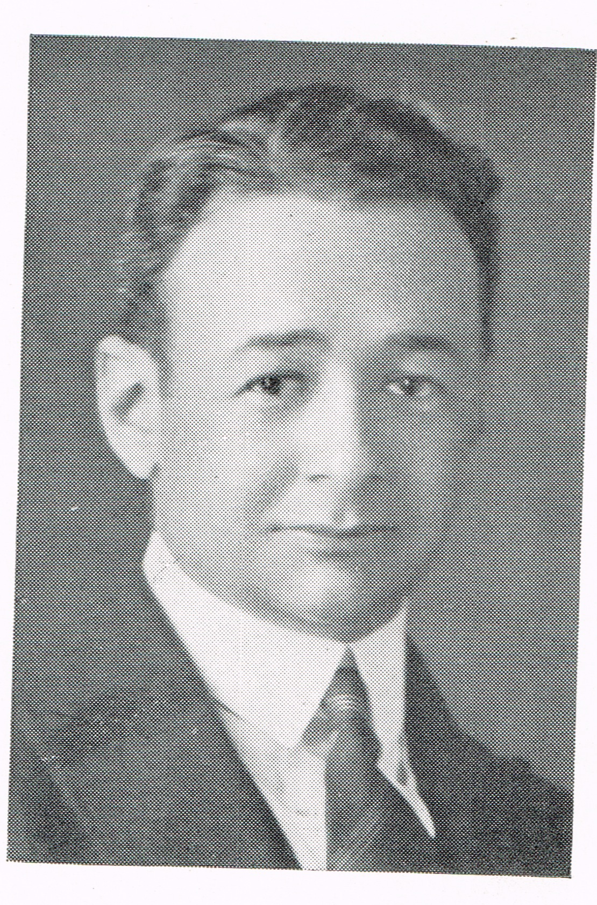
Julian B. Feibelman (1897 - 1980)
1926-1936 Assistant Rabbi at Keneseth Israel

Julian Beck Feibelman was born in Jackson, Mississippi on March 23, 1897. He graduated from Millsaps College in Jackson in 1918 with a Bachelor of Arts degree. Following his graduation, Feibelman enlisted in the Army and served 15 months at Camp Shelby, Mississippi during World War I.
After leaving the Army, Feibelman matriculated at the University of Mississippi Law School but shortly thereafter decided to enter the rabbinate and transferred to Hebrew Union College in Cincinnati in 1920. He was ordained in 1926 and went to Philadelphia to become assistant rabbi at Reform Congregation Keneseth Israel where he remained for ten years. While in Philadelphia Feibelman attended the University of Pennsylvania and earned a Master of Arts degree and a Ph.D.
In September, 1936 Feibelman came to New Orleans to become rabbi at Temple Sinai. He remained there until his retirement in 1967 when he was elected Rabbi Emeritus.
Feibelman was deeply involved in community affairs in New Orleans, working for better interfaith relations between Christians and Jews and for greater friendship and brotherhood among all persons.
During World War II, Feibelman was Chairman of the Home Service Committee and the Camp and Hospital Committee of the New Orleans Red Cross Chapter and he served as a volunteer Field Director for the Red Cross in New Orleans camps.
In 1947 he was a representative of the First World Conference on Anti-Semitism in Seeligsburg, Switzerland, which was organized by the National Conference of Christians and Jews.
Feibelman served as president of many organizations, including the Louisiana Society for Mental Health, the Louisiana Association for Mental Hygiene, the Family Service Society, the Rotary Club and the Alumni Association of the Hebrew Union College. He served on the executive boards of the Central Conference of American Rabbis, the New Orleans Urban League (of which he was a charter member), the Boy Scouts of America, the Foreign Policy Association, the Veterans Information Center, the Jewish Federation and the Jewish Community Center. In addition, he was a member of the editorial board of the Jewish Publication Society.
Feibelman was a lecturer at Tulane University in the field of World Religion. He was also Religious Director of the Southwestern Division of the National Conference of Christians and Jews.
Feibelman was active in efforts to achieve integration in New Orleans Schools and he was responsible for the first integrated meeting in New Orleans in 1949 when he invited Dr. Ralph Bunche, then Director of the United Nations Trusteeship Division, to speak at Temple Sinai after Bunche had been denied an auditorium in the city.
Feibelman received many awards during his lifetime, including an honorary Doctor of Laws degree from Millsaps College in 1946 and an honorary Doctor of Divinity degree from Hebrew Union College-Jewish Institute of Religion in 1955. He also received the Weiss Award from the National Conference of Christians and Jews in 1967, the Torch of Liberty Award from the Anti-Defamation League in 1974, the Annual Medal for Distinguished Service from St. Mary's Dominican College in 1967 and the Times-Picayune Loving Cup Award in 1968. In addition, he received citations from the Goodwill Industries and the Boy Scouts of America, who awarded him the Silver Beaver Award in 1951.
Feibelman was the author, in 1980, of his memoirs, The Making of a Rabbi. He also was editor of the New Orleans Jewish Ledger from 1940-1944.
Julian B. Feibelman died on October 10, 1980, in New Orleans at the age of 83.

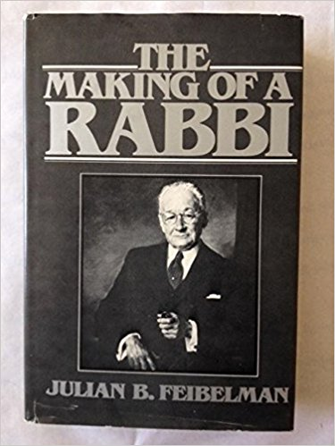
Resources:
collections.americanjewisharchives.org/ms/ms0094/ms0094.html
http://crdl.usg.edu/people/f/feibelman_julian_beck_1897/?Welcome
Confirmation Annuals 1928-1935, n.d.
Keneseth Israel 90th Anniversary 1937
Temple Bulletins 1926-1928; 1934-1935

